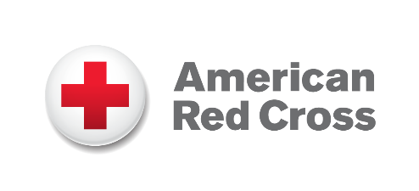
ADDITIONAL HELP AVAILABLE
December 2023

Red Cross Offering Financial Assistance

The American Red Cross has financial assistance available for people whose primary home was destroyed or is unlivable due to the Tennessee tornadoes.

To be eligible for this program, households must meet these three requirements:
- Your pre-disaster primary residence (renter or homeowner) is in a confirmed disaster-impacted geographic area in Tennessee and is either destroyed or has sustained significant structural damage that requires extensive repairs, or the damage is so severe that repairs are not feasible.
  - This may include substantial failure of the roof, walls, or foundation, or a water line above 18 inches.
- You must be able to provide proof of identity and residence.

We ask people to apply for federal Disaster Assistance at disasterassistance.gov or by calling 800-621-3362. However, approval for FEMA assistance is not a requirement to receive Red Cross financial assistance.

If you have questions about American Red Cross financial assistance or
other services call 1-800-RED CROSS (800-733-2767)

Our Mission
The American Red Cross prevents and alleviates human suffering in the face of
emergencies by mobilizing the power of volunteers and the generosity of donors.
To learn more about our work, please visit redcross.org.

